UNITED STATES
SECURITIES AND EXCHANGE COMMISSION
Washington, D.C. 20549

FORM 8-K

CURRENT REPORT
Pursuant to Section 13 or 15(d)
of the Securities Exchange Act of 1934
Date of Report (Date of earliest event reported): May 13, 2022

EMBECTA CORP.
(Exact name of registrant as specified in its charter)

Delaware
(State or Other Jurisdiction
of Incorporation)

001-41186 |  |  |  |  |  | 87-1583942
(Commission  File Number) |  |  |  |  |  | (IRS Employer  Identification No.)

300 Kimball Drive, Parsippany, New Jersey |  |  |  |  |  | 07054
(Address of principal executive offices) |  |  |  |  |  | (Zip Code)
Registrant’s telephone number, including area code: (201) 847-6880
N/A
(Former name or former address, if changed since last report)
Check the appropriate box below if the Form 8-K filing is intended to simultaneously satisfy the filing obligation of the registrant under any of the following provisions (see General Instruction A.2. below):
☐ |  |  | Written communications pursuant to Rule 425 under the Securities Act (17 CFR 230.425)
☐ |  |  | Soliciting material pursuant to Rule 14a-12 under the Exchange Act (17 CFR 240.14a-12)
☐ |  |  | Pre-commencement communications pursuant to Rule 14d-2(b) under the Exchange Act (17 CFR 240.14d-2(b))
☐ |  |  | Pre-commencement communications pursuant to Rule 13e-4(c) under the Exchange Act (17 CFR 240.13e-4(c))

Title of each class |  |  |  |  |  | Trading  symbol(s) |  |  |  |  |  | Name of each exchange  on which registered
Common Stock, par value $0.01 per share |  |  |  |  |  | EMBC |  |  |  |  |  | The Nasdaq Stock Market LLC (Nasdaq Global Select Market)
Indicate by check mark whether the registrant is an emerging growth company as defined in Rule 405 of the Securities Act of 1933 (17 CFR §230.405) or Rule 12b-2 of the Securities Exchange Act of 1934 (17 CFR §240.12b-2).
Emerging growth company ☐
If an emerging growth company, indicate by check mark if the registrant has elected not to use the extended transition period for complying with any new or revised financial accounting standards provided pursuant to Section 13(a) of the Exchange Act. ☐

Item 2.02.Results of Operations and Financial Condition.
On May 13, 2022, Embecta Corp. (the “Company” or "embecta") issued a press release (the “Earnings Release”) regarding its results for the quarter ended March 31, 2022. The Earnings Release is included as Exhibit 99.1 to this report.

Item 7.01.Regulation FD Disclosure.
In connection with the conference call announced in the Earnings Release on May 13, 2022, the Company made available the Company Information Presentation furnished with this Current Report on Form 8-K as Exhibit 99.2 (the “Investor Presentation”) and available on the Company's website, www.embecta.com, relating to, among other things, its financial results for the quarter ended March 31, 2022. The Company expects to use the Investor Presentation, in whole or in part, and possibly with immaterial modifications, in connection with presentations to investors, analysts and others during the fiscal year ending September 30, 2022.

Item 9.01.Financial Statements and Exhibits.
(d)Exhibits
The following is furnished as an exhibit to this report:

99.1 |  |  | Press Release, dated May 13, 2022.
99.2 |  |  | Company Information Presentation ("Investor Presentation")
104 |  |  | Cover Page Interactive Data File (embedded within the Inline XBRL document)

Signature
Pursuant to the requirements of the Securities Exchange Act of 1934, the registrant has duly caused this report to be signed on its behalf by the undersigned hereunto duly authorized.

 |  |  | EMBECTA CORP.
 |  |  | By: |  |  |  |  |  | /s/ Jacob Elguicze
Jacob Elguicze
Chief Financial Officer
Dated: May 13, 2022

3
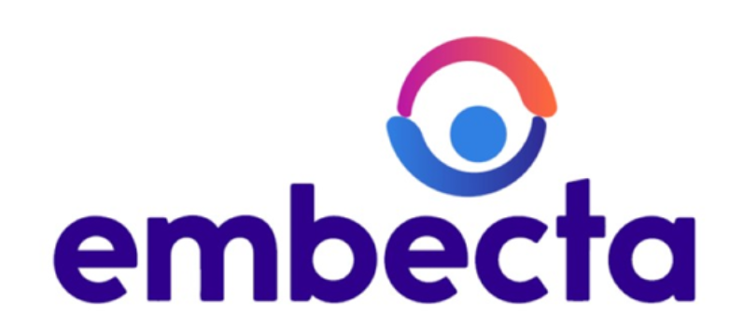

FOR IMMEDIATE RELEASE

Embecta Corp. Reports Second Quarter and First Six Months of Fiscal Year 2022 Financial Results and Provides Financial Guidance for the Last Six Months of Fiscal Year 2022

Parsippany, N.J., May 13, 2022 (GLOBE NEWSWIRE) – Embecta Corp. (“embecta”) (Nasdaq: EMBC), one of the largest pure-play diabetes care companies in the world following its April 1, 2022, spin off from Becton, Dickinson and Company ("BD"), today reported financial results for the three- and six-month periods which ended March 31, 2022, and provided financial guidance for the last six months of the fiscal year ending September 30, 2022.
“Our global team successfully executed the spin off from BD while meeting our commitments and maintaining the high level of service that our customers and the millions of people with diabetes that use our products deserve and expect,” said Devdatt “Dev” Kurdikar, Chief Executive Officer of embecta. “Listing the independent company’s stock on Nasdaq on April 1 was an inspiring and unifying day for our team around the world. It also marked the mid-point of a fiscal year in which our team has faced unprecedented global supply chain disruptions, inflationary pressures, continuing COVID-19 impacts, and geopolitical uncertainties. With the launch of embecta behind us, we are now focused on navigating these challenges while building all the capabilities required as an independent company and pursuing our strategic priorities that will allow us to progress towards our vision of a life unlimited by diabetes.”
The second quarter and first half of fiscal year 2022 and 2021 results described below are based on carve-out accounting principles, derived from the unaudited interim condensed consolidated financial statements and accounting records of BD. These condensed combined financial statements reflect the historical results of operations, financial position and cash flows of BD’s Diabetes Care Business as they were historically managed in conformity with U.S. generally accepted accounting principles (“GAAP”). In addition, these condensed combined financial statements include general corporate expenses of BD and shared segment expenses for certain support functions that are provided on a centralized basis within BD and which were not historically allocated to the BD Diabetes Care Business. Nonetheless, these financial statements do not include all the actual expenses that would have been incurred had embecta been a standalone public company during the periods presented.
Second Quarter Fiscal Year 2022 Financial Highlights:
•Revenue of $274.5 million, down 3.4% on a reported basis; down 1.3% on a constant currency basis
◦U.S. revenues declined 5.8% on both a reported and constant currency basis
◦International revenues declined 0.8% on a reported basis, and increased 3.6% on a constant currency basis
•Gross profit and margin of $191.2 million and 69.7%, compared to $196.3 million and 69.1% in the prior year period
•Net income of $79.6 million, compared to $107.9 million in the prior year period
•Adjusted EBITDA and margin of $116.8 million and 42.6%, compared to $141.6 million and 49.8% in the prior year period
Six Months Ended March 31 Fiscal Year 2022 Financial Highlights:
•Revenue of $563.8 million, down 1.0% on a reported basis; up 0.2% on a constant currency basis
◦U.S. revenues declined 2.4% and on both a reported and constant currency basis
◦International revenues increased 0.6% on a reported basis, and increased 3.1% on a constant currency basis
•Gross profit and margin of $395.1 million and 70.1%, compared to $387.6 million and 68.1% in the prior year period
•Net income of $178.4 million, compared to $213.2 million in the prior year period
•Adjusted EBITDA and margin of $254.8 million and 45.2%, compared to $289.8 million and 50.9% in the prior year period
1
Strategic Highlights:
•Completed the planned spin off from BD, giving embecta the strategic, operational, and financial independence to optimize its product portfolio and achieve more efficient resource and capital allocation to address the significant unmet need for chronic diabetes care
•Executing on transition service agreements with BD while building up embecta’s internal organization, systems and processes
•Advanced the development of a type 2 closed loop insulin delivery system utilizing embecta’s proprietary patch pump, which carries Breakthrough Device Designation from the U.S. Food & Drug Administration
•Took actions to mitigate global supply chain challenges and minimize customer and patient impact
•Continued to manage through COVID-19 disruptions in certain markets that impacted operations
Second Quarter Fiscal Year 2022 Results:
Revenues by geographic region are as follows:
 |  |  | Three months ended March 31,
Dollars in millions |  |  |  |  |  |  |  |  |  |  |  |  |  |  | Increase/(decrease)
 |  |  |  |  |  |  |  |  |  |  |  |  |  |  |  |  |  |  |  |  | As Reported |  |  |  |  |  | Constant Currency
 |  |  | 2022 |  |  |  |  |  | 2021 |  |  |  |  |  | $ |  |  |  |  |  | % |  |  |  |  |  | %
United States |  |  | $ | 139.8 |  |  |  |  | $ | 148.4 |  |  |  |  | $ | (8.6) |  |  |  |  | (5.8) |  | % |  |  |  | (5.8) |  | %
International |  |  | 134.7 |  |  |  |  |  | 135.8 |  |  |  |  |  | (1.1) |  |  |  |  |  | (0.8) |  |  |  |  |  | 3.6
Total |  |  | $ | 274.5 |  |  |  |  | $ | 284.2 |  |  |  |  | $ | (9.7) |  |  |  |  | (3.4) |  | % |  |  |  | (1.3) |  | %

Our revenues decreased by $9.7 million, or 3.4%, to $274.5 million for the second quarter of 2022 as compared to revenues of $284.2 million for the second quarter of 2021. Changes in our revenue are driven by the volume of goods that we sell, the prices we negotiate with customers and changes in foreign exchange rates. Of this decrease, $6.0 million was attributable to unfavorable effects from foreign currency translation primarily in countries with revenues denominated in Euros. Volume unfavorably impacted our revenues by approximately $3.7 million, for the three months ended March 31, 2022, as compared to the prior period. The decrease in volume was primarily driven by customers in the U.S. and Europe.
Six Months Fiscal Year 2022 Results:
Revenues by geographic region are as follows:
 |  |  | Six months ended March 31,
Dollars in millions |  |  |  |  |  |  |  |  |  |  |  |  |  |  | Increase/(decrease)
 |  |  |  |  |  |  |  |  |  |  |  |  |  |  |  |  |  |  |  |  | As Reported |  |  |  |  |  | Constant Currency
 |  |  | 2022 |  |  |  |  |  | 2021 |  |  |  |  |  | $ |  |  |  |  |  | % |  |  |  |  |  | %
United States |  |  | $ | 290.7 |  |  |  |  | $ | 297.9 |  |  |  |  | $ | (7.2) |  |  |  |  | (2.4) |  | % |  |  |  | (2.4) |  | %
International |  |  | 273.1 |  |  |  |  |  | 271.6 |  |  |  |  |  | 1.5 |  |  |  |  |  | 0.6 |  |  |  |  |  | 3.1
Total |  |  | $ | 563.8 |  |  |  |  | $ | 569.5 |  |  |  |  | $ | (5.7) |  |  |  |  | (1.0) |  | % |  |  |  | 0.2 |  | %

Our revenues decreased by $5.7 million, or 1.0%, to $563.8 million in the first six months of 2022 as compared to revenues of $569.5 million in the first six months of 2021. Changes in our revenue are driven by the volume of goods that we sell, the prices we negotiate with customers and changes in foreign exchange rates. Of this decrease, $6.9 million was attributable to unfavorable effects from foreign currency translation primarily in countries with revenues denominated in Euros and to a lesser extent unfavorable price and a decrease in volume in the U.S. This was offset by an increase in volume in certain emerging markets, which consist of countries within Eastern Europe, the Middle East, Africa, Latin America, Central and Southeast Asia as well as Mainland China.

2
Second-Half Fiscal Year Financial Guidance:
For the last six months of fiscal year 2022, the Company expects:
•Total revenue of approximately $555 million, representing a decrease of approximately 7.0%, as compared to total revenue of $596 million for the last six months of fiscal year 2021. Excluding the impact of fluctuations in foreign currency exchange rates, total revenue is expected to decrease approximately 3.5% during the last six months of fiscal year 2022, as compared to the last six months of fiscal year 2021.
◦Contract manufacturing revenue of approximately $15 million during the last six months of fiscal year 2022, as compared to none during the last six months of fiscal 2021.
•Non-GAAP gross margin for the last six months of fiscal year 2022 in the "low-60%s".
◦Non-GAAP gross margin includes the impact of contract manufacturing revenue which is expected to generate gross margin in the high-single digit percent area, as well as the impact of procurement of cannulas under a long-term supply agreement from BD.
•Expense of approximately $35 million associated with transition services agreement activities with BD.
•Adjusted EBITDA margin for the last six months of fiscal year 2022 in the "low-30%s".
We are unable to present a quantitative reconciliation of our expected adjusted gross margin, expected adjusted EBITDA and our expected adjusted EBITDA margin as we are unable to predict with reasonable certainty and without unreasonable effort the impact and timing of certain one-time items. The financial impact of these one-time items is uncertain and is dependent on various factors, including timing, and could be material to our Combined Statements of Income.
Second Quarter of Fiscal Year 2022 Earnings Conference Call:
Management will host a conference call at 8:00 a.m. Eastern Time (ET) on May 13, 2022 to discuss the results of the quarter, provide an update on its business, including financial guidance for fiscal year 2022, and host a question and answer session. Those who would like to participate may dial 800-374-1601 (U.S.) or 210-787-4744 (International) and provide access code 5596984. The call can also be accessed through a live webcast on the company's website at investors.embecta.com. An audio replay of the call will be available beginning at 11:00 a.m. ET on May 13, 2022, either on the embecta website or by telephone. The replay can be accessed by dialing 855-859-2056 (U.S.), or 404-537-3406 (International). The access code is 5596984. The webcast will be archived on the investor website for one year.

3
Condensed Combined Statements of Income
Diabetes Care Business
(Unaudited, $ in millions except share and per share amounts)

 |  |  | Three Months Ended  March 31, |  |  |  |  |  |  |  |  |  |  |  | Six Months Ended  March 31,
 |  |  | 2022 |  |  |  |  |  | 2021 |  |  |  |  |  | 2022 |  |  |  |  |  | 2021
Revenues |  |  | $ | 274.5 |  |  |  |  | $ | 284.2 |  |  |  |  | $ | 563.8 |  |  |  |  | $ | 569.5
Cost of products sold |  |  | 83.3 |  |  |  |  |  | 87.9 |  |  |  |  |  | 168.7 |  |  |  |  |  | 181.9
Gross Profit |  |  | $ | 191.2 |  |  |  |  | $ | 196.3 |  |  |  |  | $ | 395.1 |  |  |  |  | $ | 387.6
Operating expenses:
Selling and administrative expense |  |  | 66.9 |  |  |  |  |  | 55.8 |  |  |  |  |  | 129.1 |  |  |  |  |  | 109.0
Research and development expense |  |  | 18.0 |  |  |  |  |  | 14.1 |  |  |  |  |  | 34.7 |  |  |  |  |  | 28.1
Other operating expenses |  |  | 7.4 |  |  |  |  |  | — |  |  |  |  |  | 15.8 |  |  |  |  |  | —
Total Operating Expenses |  |  | $ | 92.3 |  |  |  |  | $ | 69.9 |  |  |  |  | $ | 179.6 |  |  |  |  | $ | 137.1
Operating Income |  |  | 98.9 |  |  |  |  |  | 126.4 |  |  |  |  |  | 215.5 |  |  |  |  |  | 250.5
Interest expense |  |  | (4.9) |  |  |  |  |  | — |  |  |  |  |  | (4.9) |  |  |  |  |  | —
Other income (expense), net |  |  | (0.1) |  |  |  |  |  | 2.1 |  |  |  |  |  | (0.1) |  |  |  |  |  | 3.1
Income Before Income Taxes |  |  | $ | 93.9 |  |  |  |  | $ | 128.5 |  |  |  |  | $ | 210.5 |  |  |  |  | $ | 253.6
Income tax provision |  |  | 14.3 |  |  |  |  |  | 20.6 |  |  |  |  |  | 32.1 |  |  |  |  |  | 40.4
Net Income |  |  | $ | 79.6 |  |  |  |  | $ | 107.9 |  |  |  |  | $ | 178.4 |  |  |  |  | $ | 213.2
Basic and Diluted Earnings per Share: |  |  | $ | 1.38 |  |  |  |  | $ | 1.87 |  |  |  |  | $ | 3.09 |  |  |  |  | $ | 3.69
Number of Basic and Diluted Shares Outstanding (1) |  |  | 57,797,841 |  |  |  |  |  | 57,797,841 |  |  |  |  |  | 57,797,841 |  |  |  |  |  | 57,797,841
(1) On April 1, 2022, the effective date of the spin-off, 57,797,841 shares of embecta's common stock, par value $0.01 per share, were distributed to BD shareholders of record as of March 22, 2022, the record date of the transaction. This share amount is utilized for the calculation of basic and diluted earnings per share for all periods presented prior to the spin-off. For the three and six months ended March 31, 2022 and 2021, these shares are treated as issued and outstanding for purposes of calculating historical earnings per share. For periods prior to the spin-off, it is assumed that there are no dilutive equity instruments as there were no equity awards of embecta outstanding prior to the spin-off.

4
Condensed Combined Balance Sheets
Diabetes Care Business
($ in millions)
 |  |  | March 31, 2022 |  |  |  |  |  | September 30, 2021
 |  |  | (Unaudited)
ASSETS
Current Assets
Cash and cash equivalents |  |  | $ | 264.3 |  |  |  |  | $ | —
Trade receivables, net |  |  | 15.2 |  |  |  |  |  | 150.6
Inventories:
Materials |  |  | 12.3 |  |  |  |  |  | 13.1
Work in process |  |  | 17.5 |  |  |  |  |  | 21.0
Finished products |  |  | 92.6 |  |  |  |  |  | 83.9
 |  |  | $ | 122.4 |  |  |  |  | $ | 118.0
Prepaid expenses and other |  |  | 24.6 |  |  |  |  |  | 23.2
Total Current Assets |  |  | $ | 426.5 |  |  |  |  | $ | 291.8
Property, Plant and Equipment, Net |  |  | 355.7 |  |  |  |  |  | 451.0
Goodwill and Other Intangible Assets |  |  | 34.7 |  |  |  |  |  | 33.9
Other Assets |  |  | 16.6 |  |  |  |  |  | 11.3
Total Assets |  |  | $ | 833.5 |  |  |  |  | $ | 788.0
LIABILITIES AND PARENT’S EQUITY
Current Liabilities
Accounts payable |  |  | $ | 50.8 |  |  |  |  | $ | 54.2
Accrued expenses |  |  | 76.6 |  |  |  |  |  | 81.6
Salaries, wages and related items |  |  | 23.5 |  |  |  |  |  | 28.2
Current debt obligations |  |  | 9.5 |  |  |  |  |  | —
Income Taxes |  |  | 8.5 |  |  |  |  |  | —
Total Current Liabilities |  |  | $ | 168.9 |  |  |  |  | $ | 164.0
Deferred Income Taxes and Other Liabilities |  |  | 31.4 |  |  |  |  |  | 29.7
Long-Term Debt |  |  | 1,403.7 |  |  |  |  |  | —
Related Party Note Payable |  |  | 197.0 |  |  |  |  |  | —
Commitments and Contingencies (Note 5) |  |  | — |  |  |  |  |  | —
Parent’s Equity
Net parent investment |  |  | (681.1) |  |  |  |  |  | 864.8
Accumulated other comprehensive loss |  |  | (286.4) |  |  |  |  |  | (270.5)
Total Parent’s Equity |  |  | $ | (967.5) |  |  |  |  | $ | 594.3
Total Liabilities and Parent’s Equity |  |  | $ | 833.5 |  |  |  |  | $ | 788.0

5
Condensed Combined Statements of Cash Flows
Diabetes Care Business
(Unaudited, $ in millions)

Six Months Ended
March 31,
 |  |  | 2022 |  |  |  |  |  | 2021
Operating Activities
Net income |  |  | $ | 178.4 |  |  |  |  | $ | 213.2
Adjustments to net income to derive net cash provided by operating activities:
Depreciation and amortization |  |  | 15.1 |  |  |  |  |  | 19.5
Amortization of debt issuance costs |  |  | 0.1 |  |  |  |  |  | —
Impairment of property, plant and equipment |  |  | — |  |  |  |  |  | 10.0
Share-based compensation |  |  | 8.5 |  |  |  |  |  | 6.7
Pension expense |  |  | 3.6 |  |  |  |  |  | 4.9
Change in operating assets and liabilities:
Trade receivables, net |  |  | 133.3 |  |  |  |  |  | 0.6
Inventories |  |  | (10.0) |  |  |  |  |  | (9.1)
Prepaid expenses and other |  |  | (2.4) |  |  |  |  |  | (5.8)
Accounts payable |  |  | (2.9) |  |  |  |  |  | (13.8)
Accrued expenses |  |  | (8.5) |  |  |  |  |  | 13.6
Other current liabilities |  |  | 5.8 |  |  |  |  |  | 1.1
Other, net |  |  | 0.4 |  |  |  |  |  | 0.2
Net Cash Provided by Operating Activities |  |  | $ | 321.4 |  |  |  |  | $ | 241.1
Investing Activities
Capital expenditures |  |  | (9.7) |  |  |  |  |  | (16.6)
Acquisition of intangible assets |  |  | (0.4) |  |  |  |  |  | (1.6)
Net Cash Used for Investing Activities |  |  | $ | (10.1) |  |  |  |  | $ | (18.2)
Financing Activities
Proceeds from the issuance of long-term debt |  |  | 1,450.0 |  |  |  |  |  | —
Payment of long-term debt issuance costs |  |  | (33.3) |  |  |  |  |  | —
Net consideration paid to Parent in connection with the spin off |  |  | (1,266.0) |  |  |  |  |  | —
Payment of revolving credit facility fees |  |  | (5.6) |  |  |  |  |  | —
Net transfers to Parent |  |  | (189.3) |  |  |  |  |  | (222.9)
Net Cash Used for Financing Activities |  |  | $ | (44.2) |  |  |  |  | $ | (222.9)
Effect of exchange rate changes on cash and cash equivalents |  |  | (2.8) |  |  |  |  |  | —
Net Change in Cash and cash equivalents |  |  | $ | 264.3 |  |  |  |  | $ | —
Opening Cash and cash equivalents |  |  | — |  |  |  |  |  | —
Closing Cash and cash equivalents |  |  | $ | 264.3 |  |  |  |  | $ | —

6
Non-GAAP financial measures
In evaluating our operating performance, we supplement the reporting of our financial information determined under GAAP with certain non-GAAP financial measures including (i) earnings before interest, taxes, depreciation, and amortization (“EBITDA”), (ii) adjusted EBITDA, as further defined below, and (iii) Constant Currency revenue growth. These non-GAAP financial measures are indicators of our performance that are not required by, or presented in accordance with, GAAP. They are presented with the intent of providing greater transparency to financial information used by us in our financial analysis and operational decision-making. We believe that these non-GAAP measures provide meaningful information to assist investors, shareholders and other readers of our consolidated financial statements in making comparisons to our historical operating results and analyzing the underlying performance of our results of operations. Additionally, EBITDA and Adjusted EBITDA are important metrics for debt investors who utilize debt-to-EBITDA ratios. These non-GAAP financial measures are not intended to be, and should not be, considered separately from, or as an alternative to, the most directly comparable GAAP financial measures.
We believe EBITDA is an important valuation measurement for management and investors given the effect non-cash charges such as amortization related to acquired intangible assets and depreciation of capital equipment have on net income. Additionally, we regard EBITDA as a useful measure of operating performance and cash flow before the effect of interest, taxes, depreciation and amortization and as a complement to operating income, net income and other GAAP financial performance measures. We define adjusted EBITDA as EBITDA excluding certain items that affect comparability of operating results and the trend of earnings. These adjustments are either non-cash or irregular in nature, may not be indicative of our past and future performance and are therefore excluded to allow investors to better understand underlying operating trends. The following are examples of the types of adjustments that are excluded: (i) share-based compensation, (ii) impairment losses incurred, (iii) separation costs associated with our spin-off from BD, and (iv) other significant items management deems irregular or non-operating in nature. We use adjusted EBITDA when evaluating operating performance because we believe the exclusion of such adjustments is necessary to help provide an accurate measure of on-going core operating results and to evaluate comparative results period over period.
For the three and six month periods ended March 31, 2022, the reconciliation of net income to EBITDA and adjusted EBITDA was as follows:
 |  |  | Three Months Ended  March 31, |  |  |  |  |  |  |  |  |  |  |  | Six Months Ended  March 31,
Dollars in millions
 |  |  | 2022 |  |  |  |  |  | 2021 |  |  |  |  |  | 2022 |  |  |  |  |  | 2021
Net income |  |  | $ | 79.6 |  |  |  |  | $ | 107.9 |  |  |  |  | $ | 178.4 |  |  |  |  | $ | 213.2
Interest expense |  |  | 4.9 |  |  |  |  |  | — |  |  |  |  |  | 4.9 |  |  |  |  |  | —
Income taxes |  |  | 14.3 |  |  |  |  |  | 20.6 |  |  |  |  |  | 32.1 |  |  |  |  |  | 40.4
Depreciation |  |  | 6.4 |  |  |  |  |  | 9.7 |  |  |  |  |  | 14.8 |  |  |  |  |  | 19.0
Amortization of intangible assets |  |  | 0.3 |  |  |  |  |  | 0.5 |  |  |  |  |  | 0.3 |  |  |  |  |  | 0.5
EBITDA |  |  | 105.5 |  |  |  |  |  | 138.7 |  |  |  |  |  | 230.5 |  |  |  |  |  | 273.1
Share-based compensation expense |  |  | 3.9 |  |  |  |  |  | 2.9 |  |  |  |  |  | 8.5 |  |  |  |  |  | 6.7
Separation costs (1) |  |  | 7.4 |  |  |  |  |  | — |  |  |  |  |  | 15.8 |  |  |  |  |  | —
Impairment losses (2) |  |  | — |  |  |  |  |  | — |  |  |  |  |  | — |  |  |  |  |  | 10.0
Adjusted EBITDA |  |  | $ | 116.8 |  |  |  |  | $ | 141.6 |  |  |  |  | $ | 254.8 |  |  |  |  | $ | 289.8
(1)Relates to spin-off costs incurred during the three and six month periods ended March 31, 2022.
(2)Relates to impairment charges incurred during fiscal year 2021.
Each reporting period, we face currency exposure that arises from translating the results of our worldwide operations to the U.S. dollar at exchange rates that fluctuate from the beginning of such period. A stronger U.S. dollar, compared to the prior-year period, resulted in an unfavorable foreign currency translation impact to our revenues as compared to the prior-year quarter. We evaluate our results of operations on both a reported and a Constant Currency basis, which excludes the impact of fluctuations in foreign currency exchange rates by comparing results between periods as if exchange rates had remained constant period-over-period. As exchange rates are an important factor in understanding period-to-period comparisons, we believe the presentation of results on a Constant Currency basis in addition to reported results helps improve investors’ ability to understand our operating results and evaluate our performance in comparison to prior periods. We calculate Constant Currency percentages by converting our current-period local currency financial results using the prior-period foreign currency exchange rates and comparing these adjusted amounts to our current-period results. These results should be considered in addition to, not as a substitute for, results reported in accordance with GAAP. Results on a Constant Currency basis, as we present them,

7
may not be comparable to similarly titled measures used by other companies and are not measures of performance presented in accordance with GAAP.
For the three and six month periods ended March 31, 2022, the reconciliation of revenue growth to Constant Currency was as follows:
 |  |  | Three months ended March 31,
Dollars in millions |  |  | 2022 |  |  |  |  |  | 2021 |  |  |  |  |  | Total  Change |  |  |  |  |  | Estimated FX  Impact |  |  |  |  |  | Constant  Currency  Change
Total Revenues |  |  | $ | 274.5 |  |  |  |  | $ | 284.2 |  |  |  |  | (3.4) |  | % |  |  |  | (2.1) |  | % |  |  |  | (1.3) |  | %
 |  |  | Six months ended March 31,
Dollars in millions |  |  | 2022 |  |  |  |  |  | 2021 |  |  |  |  |  | Total  Change |  |  |  |  |  | Estimated FX  Impact |  |  |  |  |  | Constant  Currency  Change
Total Revenues |  |  | $ | 563.8 |  |  |  |  | $ | 569.5 |  |  |  |  | (1.0) |  | % |  |  |  | (1.2) |  | % |  |  |  | 0.2 |  | %
About embecta
embecta, formerly part of BD (Becton, Dickinson and Company), is one of the largest pure-play diabetes care companies in the world, leveraging its nearly 100-year legacy in insulin delivery to empower people with diabetes to live their best life through innovative solutions, partnerships and the passion of more than 2,000 employees around the globe. For more information, visit embecta.com, the content of which is not a part of this press release.
Safe Harbor Statement Regarding Forward-Looking Statements
This press release contains express or implied "forward-looking statements" as that term is defined in the Private Securities Litigation Reform Act of 1995 and other securities laws. These forward-looking statements concern our current expectations regarding our future results from operations, performance, financial condition, goals, strategies, plans and achievements. These forward-looking statements are subject to various known and unknown risks, uncertainties and other factors, and you should not rely upon them except as statements of our present intentions and of our present expectations, which may or may not occur. When we use words such as "believes," "expects," "anticipates," "estimates," "plans," "intends", “pursue”, “will” or similar expressions, we are making forward-looking statements. For example, embecta is using forward-looking statements when it discusses its fiscal 2022 financial guidance and its capabilities as an independent company and strategic priorities, including its ability to optimize its product portfolio and achieve more efficient resource and capital allocation. Although we believe that our forward-looking statements are based on reasonable assumptions, our expected results may not be achieved, and actual results may differ materially from our expectations. In addition, important factors that could cause actual results to differ from expectations include, among others: (i) competitive factors that could adversely affect embecta’s operations, (ii) any events that adversely affect the sale or profitability of embecta’s products or the revenue delivered from sales to its customers, (iii) any failure by BD to perform of its obligations under the various separation agreements entered into in connection with the separation and distribution; (iv) increases in operating costs, including fluctuations in the cost and availability of raw materials or components used in its products, the ability to maintain favorable supplier arrangements and relationships, and the potential adverse effects of any disruption in the availability of such items; (v) changes in reimbursement practices of governments or private payers or other cost containment measures; (vi) the adverse financial impact resulting from unfavorable changes in foreign currency exchange rates, as well as regional, national and foreign economic factors, including inflation, deflation, and fluctuations in interest rates; (vii) the impact of changes in U.S. federal laws and policy that could affect fiscal and tax policies, healthcare and international trade, including import and export regulation and international trade agreements; (viii) any impact of the COVID-19 pandemic, including disruptions in its operations and supply chains; (ix) new or changing laws and regulations, or changes in enforcement practices, including laws relating to healthcare, environmental protection, trade, monetary and fiscal policies, taxation and licensing and regulatory requirements for products; (x) the expected benefits of the separation from BD; (xi) risks associated with embecta’s indebtedness; (xii) the risk that embecta’s separation from BD will be more difficult or costly than expected; and (xiii) the other risks described in our periodic reports filed with the Securities and Exchange Commission (“SEC”), including under the caption “Risk Factors” in our Information Statement dated February 11, 2022, filed with the SEC on

8
February 11, 2022 as Exhibit 99.1 to our Current Report on Form 8-K. Except as required by law, we undertake no obligation to update any forward-looking statements appearing in this release.

CONTACTS
Investors:
https://investors.embecta.com/shareholder-services/contact-ir
Media:
Christian Glazar Sr. Director, Corporate Communications
908-821-6922
Christian.Glazar@embecta.com

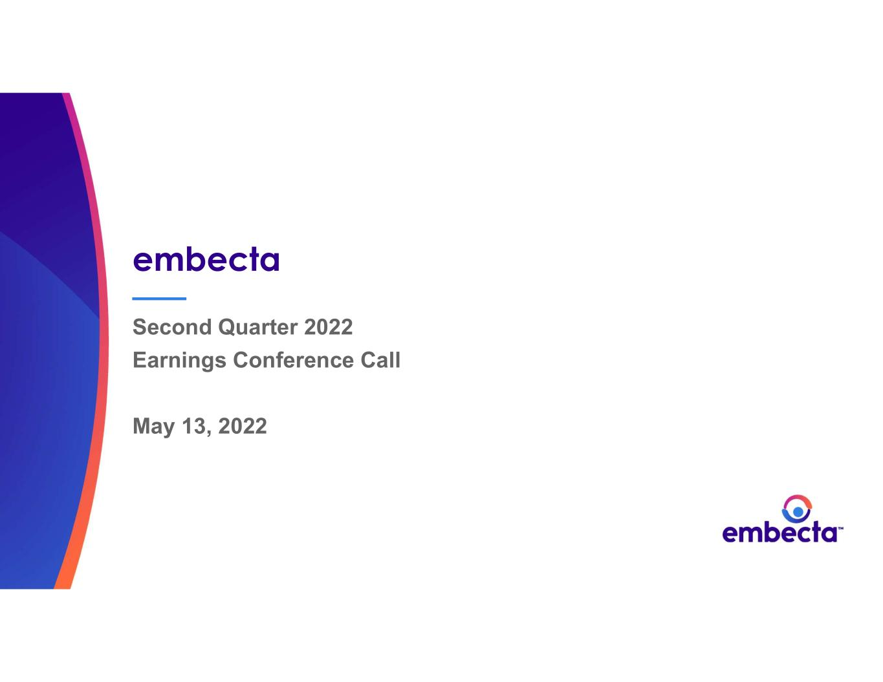

9
embecta Second Quarter 2022 Earnings Conference Call May 13, 2022

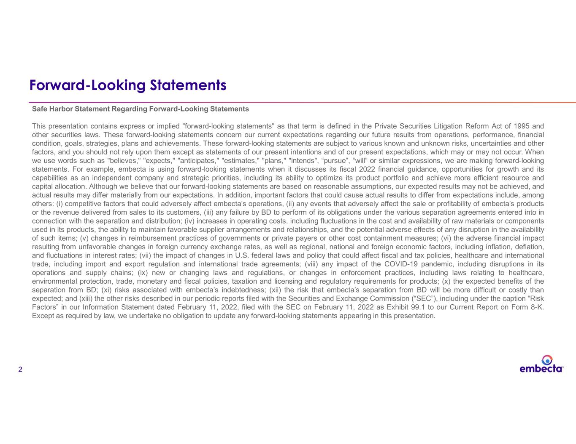
2 Forward-Looking Statements Safe Harbor Statement Regarding Forward-Looking Statements This presentation contains express or implied "forward-looking statements" as that term is defined in the Private Securities Litigation Reform Act of 1995 and other securities laws. These forward-looking statements concern our current expectations regarding our future results from operations, performance, financial condition, goals, strategies, plans and achievements. These forward-looking statements are subject to various known and unknown risks, uncertainties and other factors, and you should not rely upon them except as statements of our present intentions and of our present expectations, which may or may not occur. When we use words such as "believes," "expects," "anticipates," "estimates," "plans," "intends", “pursue”, “will” or similar expressions, we are making forward-looking statements. For example, embecta is using forward-looking statements when it discusses its fiscal 2022 financial guidance, opportunities for growth and its capabilities as an independent company and strategic priorities, including its ability to optimize its product portfolio and achieve more efficient resource and capital allocation. Although we believe that our forward-looking statements are based on reasonable assumptions, our expected results may not be achieved, and actual results may differ materially from our expectations. In addition, important factors that could cause actual results to differ from expectations include, among others: (i) competitive factors that could adversely affect embecta’s operations, (ii) any events that adversely affect the sale or profitability of embecta’s products or the revenue delivered from sales to its customers, (iii) any failure by BD to perform of its obligations under the various separation agreements entered into in connection with the separation and distribution; (iv) increases in operating costs, including fluctuations in the cost and availability of raw materials or components used in its products, the ability to maintain favorable supplier arrangements and relationships, and the potential adverse effects of any disruption in the availability of such items; (v) changes in reimbursement practices of governments or private payers or other cost containment measures; (vi) the adverse financial impact resulting from unfavorable changes in foreign currency exchange rates, as well as regional, national and foreign economic factors, including inflation, deflation, and fluctuations in interest rates; (vii) the impact of changes in U.S. federal laws and policy that could affect fiscal and tax policies, healthcare and international trade, including import and export regulation and international trade agreements; (viii) any impact of the COVID-19 pandemic, including disruptions in its operations and supply chains; (ix) new or changing laws and regulations, or changes in enforcement practices, including laws relating to healthcare, environmental protection, trade, monetary and fiscal policies, taxation and licensing and regulatory requirements for products; (x) the expected benefits of the separation from BD; (xi) risks associated with embecta’s indebtedness; (xii) the risk that embecta’s separation from BD will be more difficult or costly than expected; and (xiii) the other risks described in our periodic reports filed with the Securities and Exchange Commission (“SEC”), including under the caption “Risk Factors” in our Information Statement dated February 11, 2022, filed with the SEC on February 11, 2022 as Exhibit 99.1 to our Current Report on Form 8-K. Except as required by law, we undertake no obligation to update any forward-looking statements appearing in this presentation.

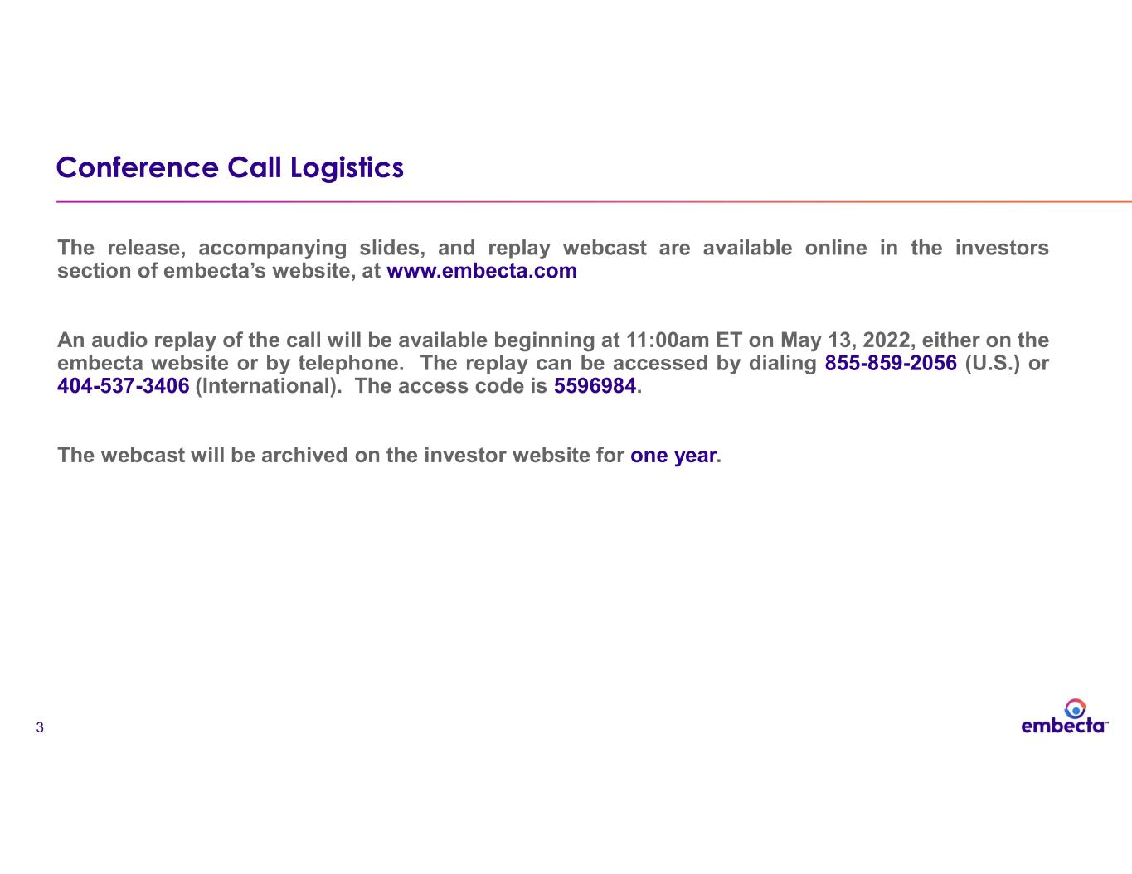
3 Conference Call Logistics The release, accompanying slides, and replay webcast are available online in the investors section of embecta’s website, at www.embecta.com An audio replay of the call will be available beginning at 11:00am ET on May 13, 2022, either on the embecta website or by telephone. The replay can be accessed by dialing 855-859-2056 (U.S.) or 404-537-3406 (International). The access code is 5596984. The webcast will be archived on the investor website for one year.


4 Today’s Speakers Dev Kurdikar Chief Executive Officer Jake Elguicze Chief Financial Officer

5 Mission To develop and provide solutions that make life better for people living with diabetes Vision A life unlimited by diabetes Advance every day together Spin from BD completed and independent company as of April 1, 2022

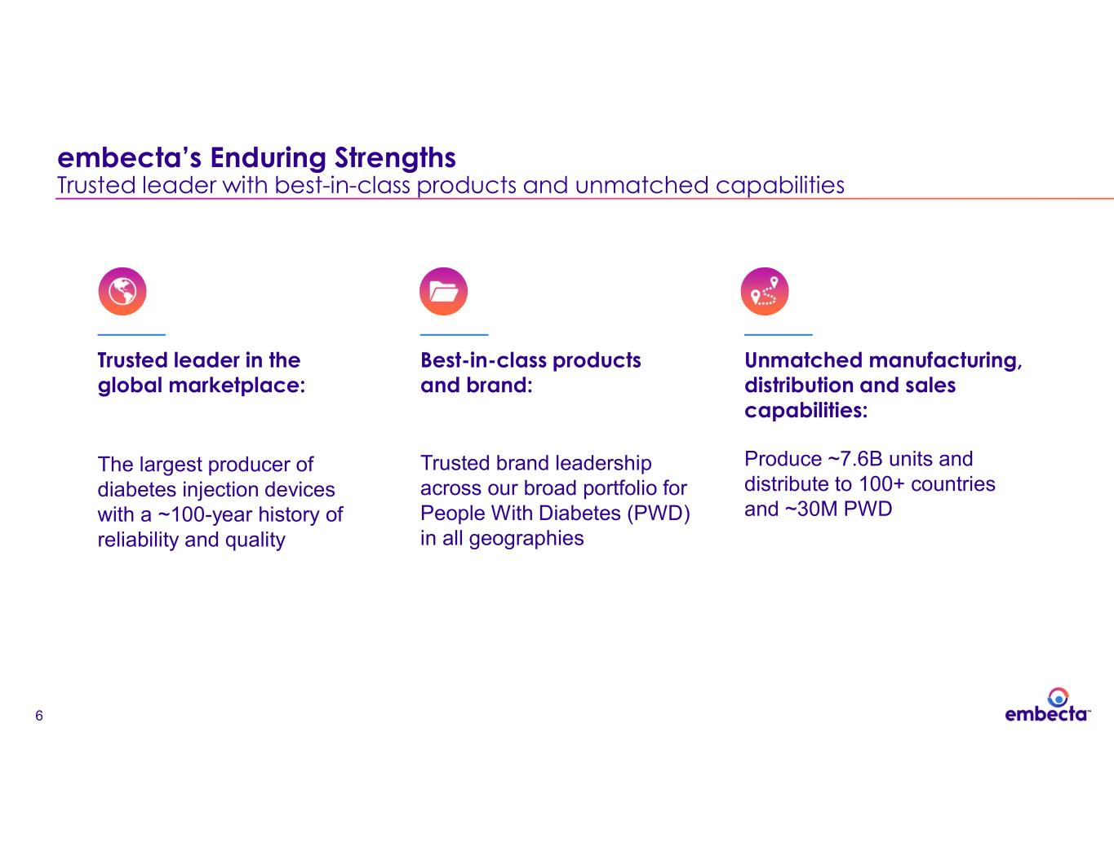
6 Trusted leader in the global marketplace: The largest producer of diabetes injection devices with a ~100-year history of reliability and quality Best-in-class products and brand: Trusted brand leadership across our broad portfolio for People With Diabetes (PWD) in all geographies Unmatched manufacturing, distribution and sales capabilities: Produce ~7.6B units and distribute to 100+ countries and ~30M PWD embecta’s Enduring Strengths Trusted leader with best-in-class products and unmatched capabilities

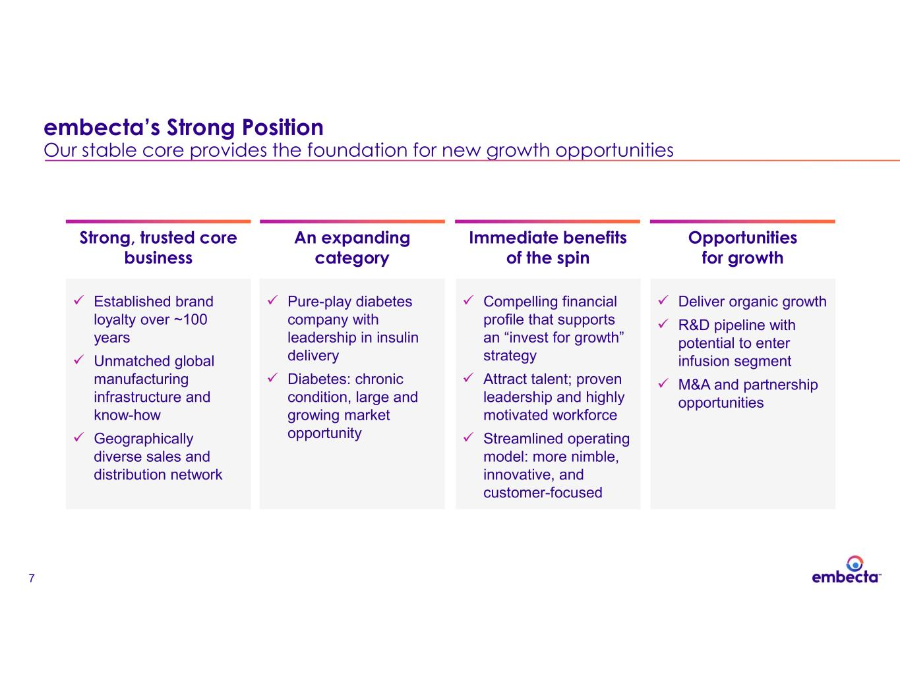
7 An expanding category ✓ Pure-play diabetes company with leadership in insulin delivery ✓ Diabetes: chronic condition, large and growing market opportunity Strong, trusted core business ✓ Established brand loyalty over ~100 years ✓ Unmatched global manufacturing infrastructure and know-how ✓ Geographically diverse sales and distribution network Immediate benefits of the spin ✓ Compelling financial profile that supports an “invest for growth” strategy ✓ Attract talent; proven leadership and highly motivated workforce ✓ Streamlined operating model: more nimble, innovative, and customer-focused Opportunities for growth ✓ Deliver organic growth ✓ R&D pipeline with potential to enter infusion segment ✓ M&A and partnership opportunities embecta’s Strong Position Our stable core provides the foundation for new growth opportunities

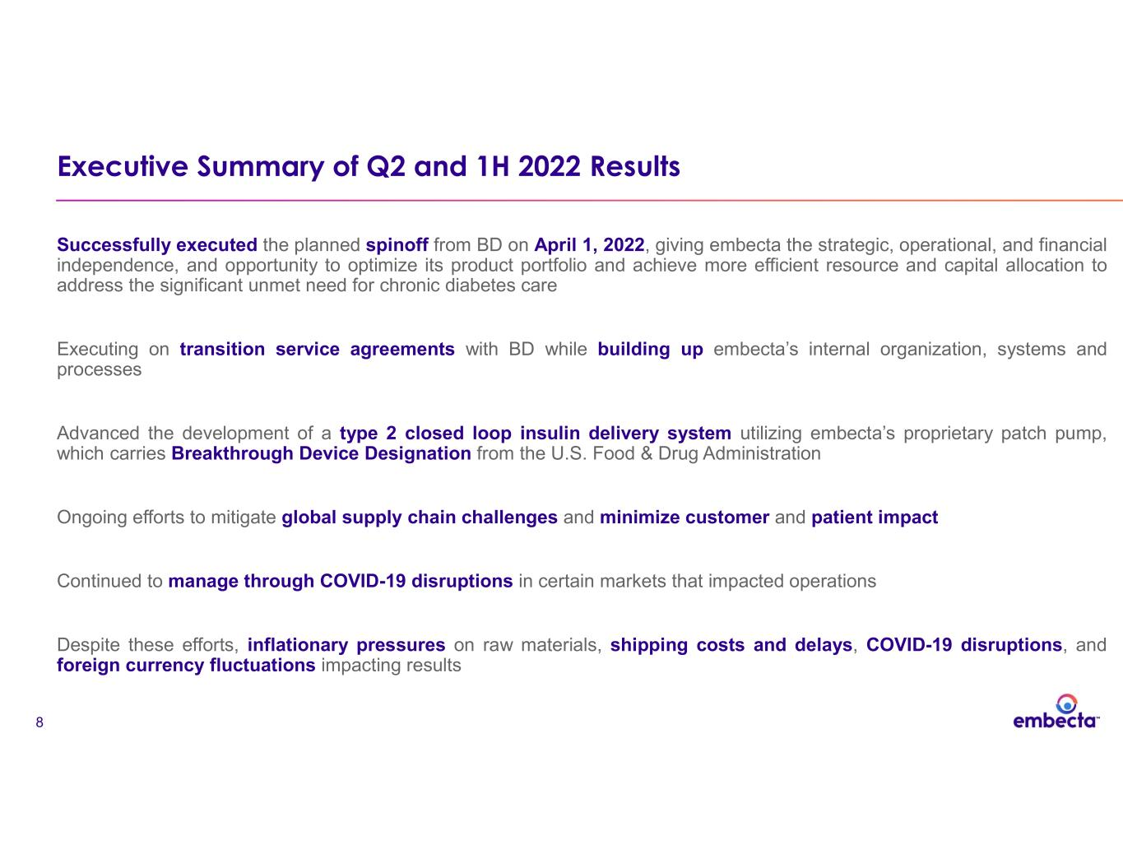
8 Executive Summary of Q2 and 1H 2022 Results Successfully executed the planned spinoff from BD on April 1, 2022, giving embecta the strategic, operational, and financial independence, and opportunity to optimize its product portfolio and achieve more efficient resource and capital allocation to address the significant unmet need for chronic diabetes care Executing on transition service agreements with BD while building up embecta’s internal organization, systems and processes Advanced the development of a type 2 closed loop insulin delivery system utilizing embecta’s proprietary patch pump, which carries Breakthrough Device Designation from the U.S. Food & Drug Administration Ongoing efforts to mitigate global supply chain challenges and minimize customer and patient impact Continued to manage through COVID-19 disruptions in certain markets that impacted operations Despite these efforts, inflationary pressures on raw materials, shipping costs and delays, COVID-19 disruptions, and foreign currency fluctuations impacting results

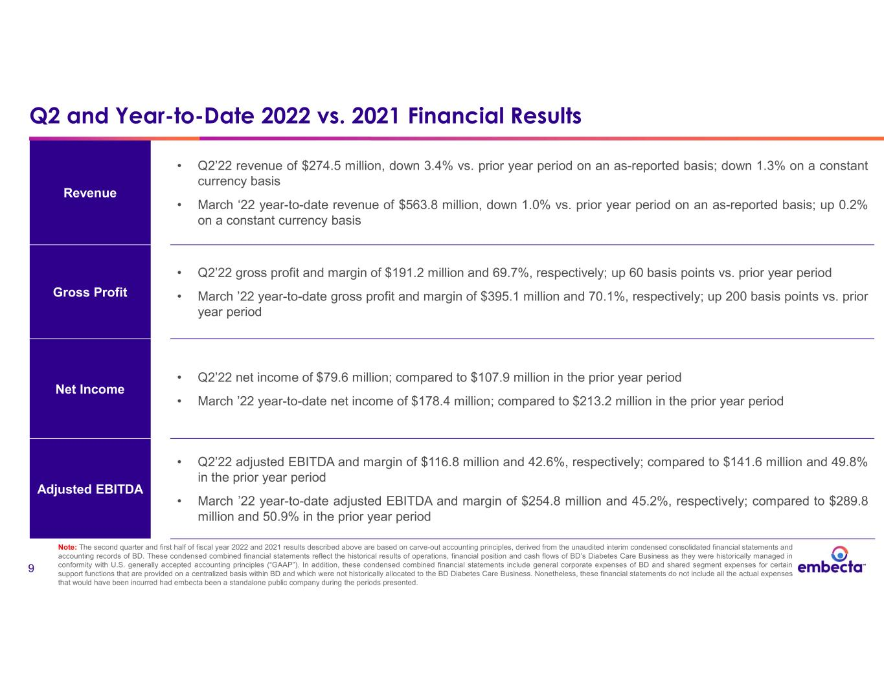
9 Revenue • Q2’22 revenue of $274.5 million, down 3.4% vs. prior year period on an as-reported basis; down 1.3% on a constant currency basis • March ‘22 year-to-date revenue of $563.8 million, down 1.0% vs. prior year period on an as-reported basis; up 0.2% on a constant currency basis Gross Profit • Q2’22 gross profit and margin of $191.2 million and 69.7%, respectively; up 60 basis points vs. prior year period • March ’22 year-to-date gross profit and margin of $395.1 million and 70.1%, respectively; up 200 basis points vs. prior year period Net Income • Q2’22 net income of $79.6 million; compared to $107.9 million in the prior year period • March ’22 year-to-date net income of $178.4 million; compared to $213.2 million in the prior year period Adjusted EBITDA • Q2’22 adjusted EBITDA and margin of $116.8 million and 42.6%, respectively; compared to $141.6 million and 49.8% in the prior year period • March ’22 year-to-date adjusted EBITDA and margin of $254.8 million and 45.2%, respectively; compared to $289.8 million and 50.9% in the prior year period Q2 and Year-to-Date 2022 vs. 2021 Financial Results Note: The second quarter and first half of fiscal year 2022 and 2021 results described above are based on carve-out accounting principles, derived from the unaudited interim condensed consolidated financial statements and accounting records of BD. These condensed combined financial statements reflect the historical results of operations, financial position and cash flows of BD’s Diabetes Care Business as they were historically managed in conformity with U.S. generally accepted accounting principles (“GAAP”). In addition, these condensed combined financial statements include general corporate expenses of BD and shared segment expenses for certain support functions that are provided on a centralized basis within BD and which were not historically allocated to the BD Diabetes Care Business. Nonetheless, these financial statements do not include all the actual expenses that would have been incurred had embecta been a standalone public company during the periods presented.

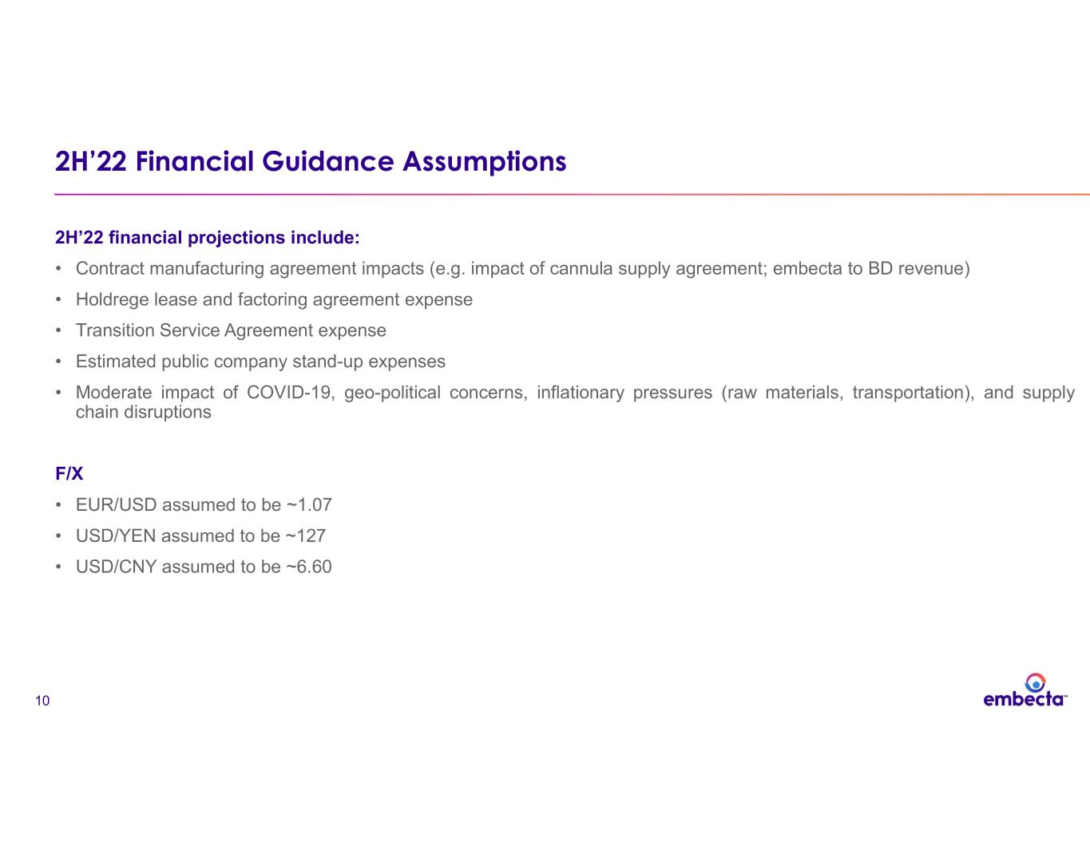
10 2H’22 Financial Guidance Assumptions 2H’22 financial projections include: • Contract manufacturing agreement impacts (e.g. impact of cannula supply agreement; embecta to BD revenue) • Holdrege lease and factoring agreement expense • Transition Service Agreement expense • Estimated public company stand-up expenses • Moderate impact of COVID-19, geo-political concerns, inflationary pressures (raw materials, transportation), and supply chain disruptions F/X • EUR/USD assumed to be ~1.07 • USD/YEN assumed to be ~127 • USD/CNY assumed to be ~6.60

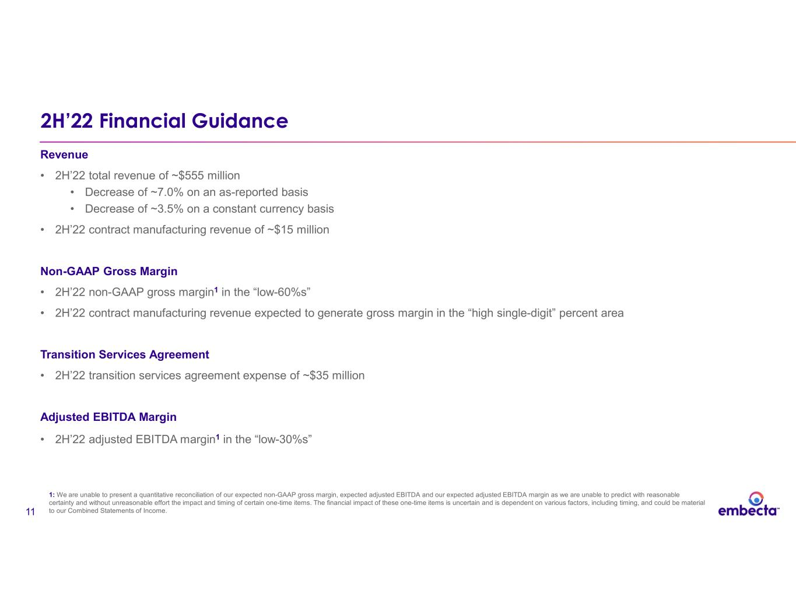
11 2H’22 Financial Guidance Revenue • 2H’22 total revenue of ~$555 million • Decrease of ~7.0% on an as-reported basis • Decrease of ~3.5% on a constant currency basis • 2H’22 contract manufacturing revenue of ~$15 million Non-GAAP Gross Margin • 2H’22 non-GAAP gross margin1 in the “low-60%s” • 2H’22 contract manufacturing revenue expected to generate gross margin in the “high single-digit” percent area Transition Services Agreement • 2H’22 transition services agreement expense of ~$35 million Adjusted EBITDA Margin • 2H’22 adjusted EBITDA margin1 in the “low-30%s” 1: We are unable to present a quantitative reconciliation of our expected non-GAAP gross margin, expected adjusted EBITDA and our expected adjusted EBITDA margin as we are unable to predict with reasonable certainty and without unreasonable effort the impact and timing of certain one-time items. The financial impact of these one-time items is uncertain and is dependent on various factors, including timing, and could be material to our Combined Statements of Income.

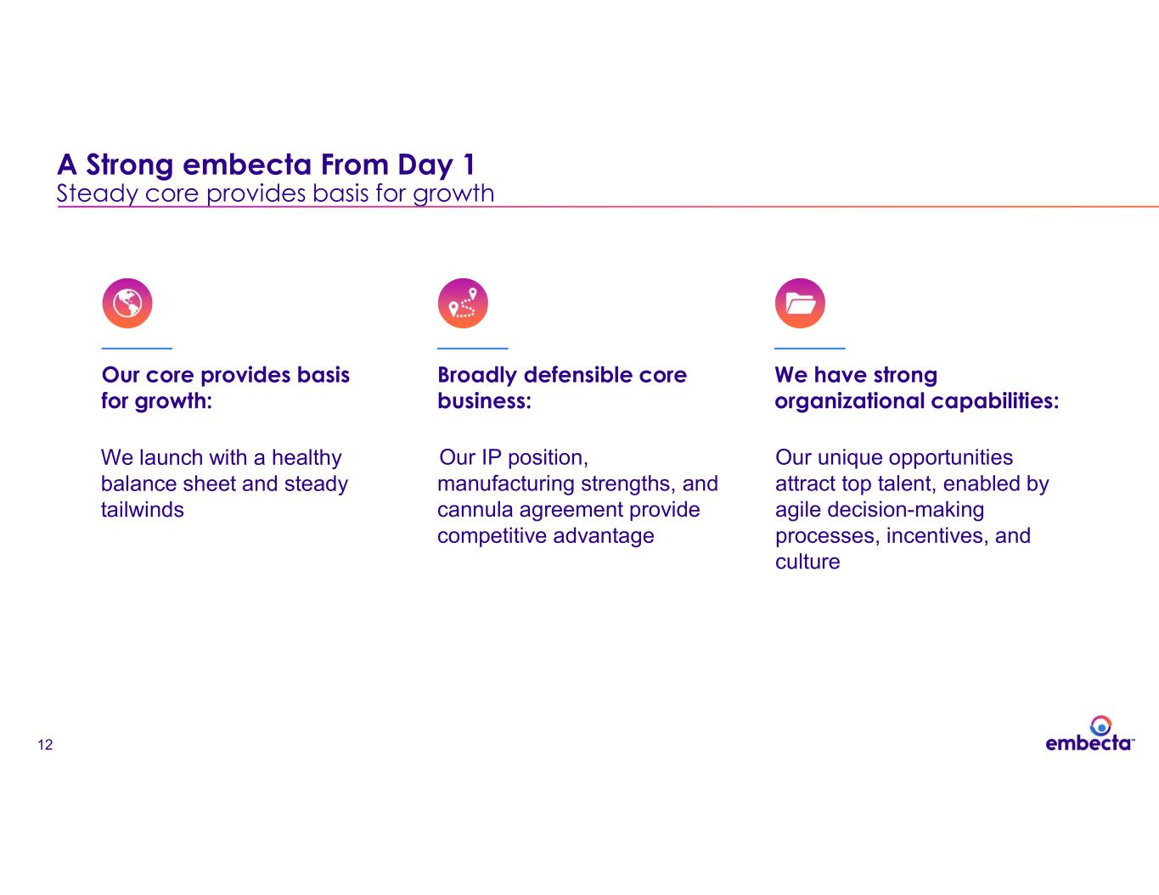
12 Our core provides basis for growth: Broadly defensible core business: We have strong organizational capabilities: A Strong embecta From Day 1 Steady core provides basis for growth We launch with a healthy balance sheet and steady tailwinds Our IP position, manufacturing strengths, and cannula agreement provide competitive advantage Our unique opportunities attract top talent, enabled by agile decision-making processes, incentives, and culture

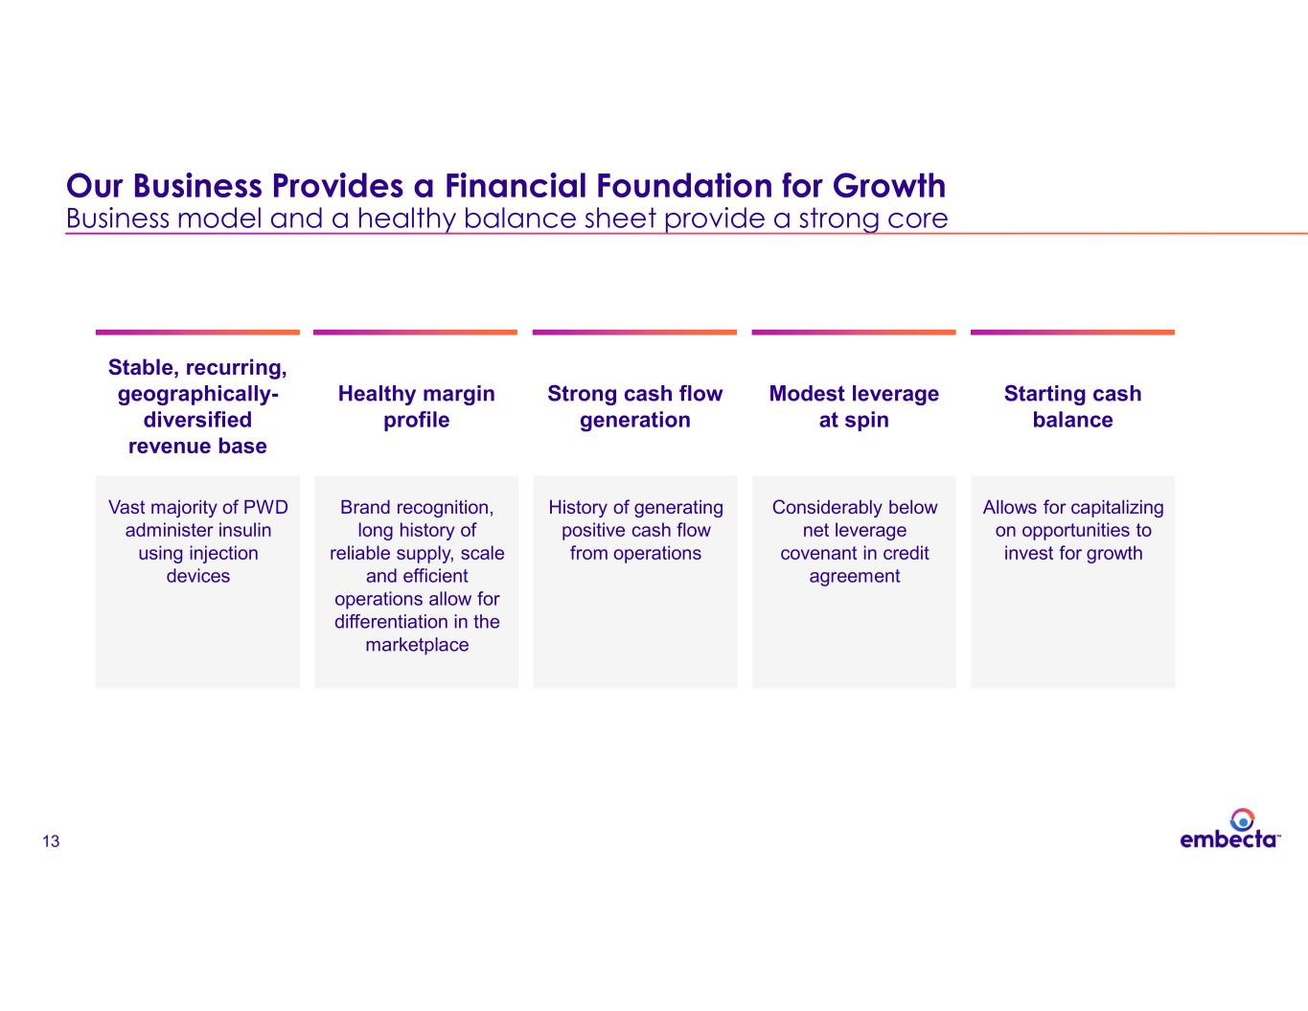
13 Our Business Provides a Financial Foundation for Growth Business model and a healthy balance sheet provide a strong core Stable, recurring, geographically- diversified revenue base Vast majority of PWD administer insulin using injection devices Healthy margin profile Brand recognition, long history of reliable supply, scale and efficient operations allow for differentiation in the marketplace Strong cash flow generation History of generating positive cash flow from operations Modest leverage at spin Considerably below net leverage covenant in credit agreement Starting cash balance Allows for capitalizing on opportunities to invest for growth

14 Expand and penetrate through the core: We have opportunities to drive growth in the core portfolio and serve unmet needs Stronger R&D: We can enter the T2D market with our patch pump, while continuing to drive injection innovation M&A potential: We will seek partnerships and acquisitions where embecta can add value through our commercial capabilities and manufacturing expertise Strategic Investments to Accelerate our Long-term Growth Profile Including commercial investments, next-gen products, and M&A

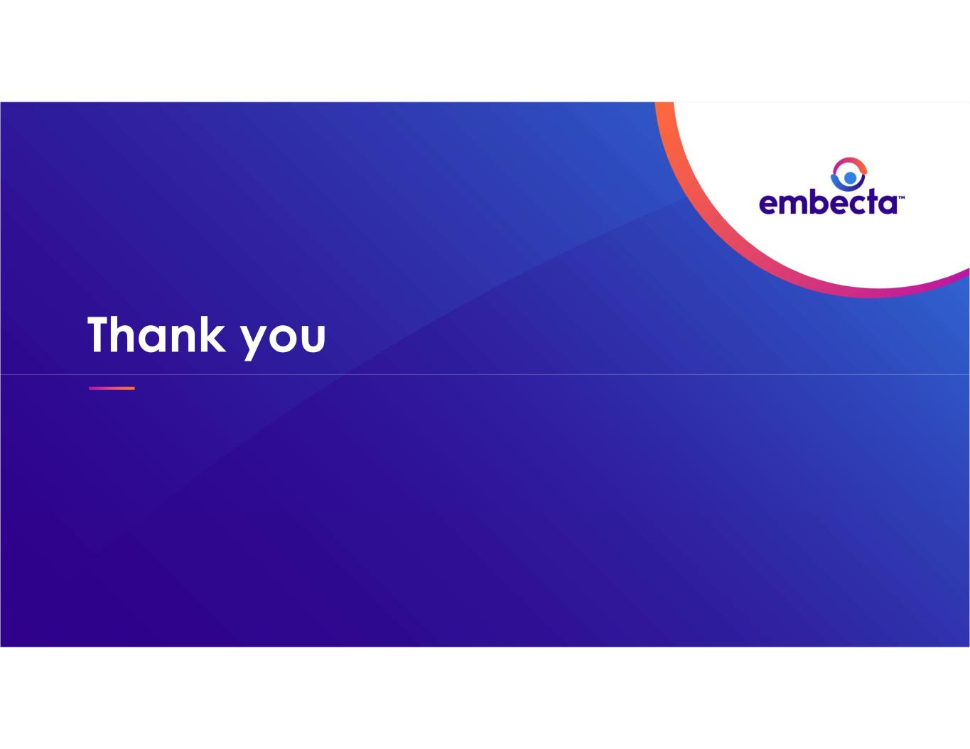
Thank you

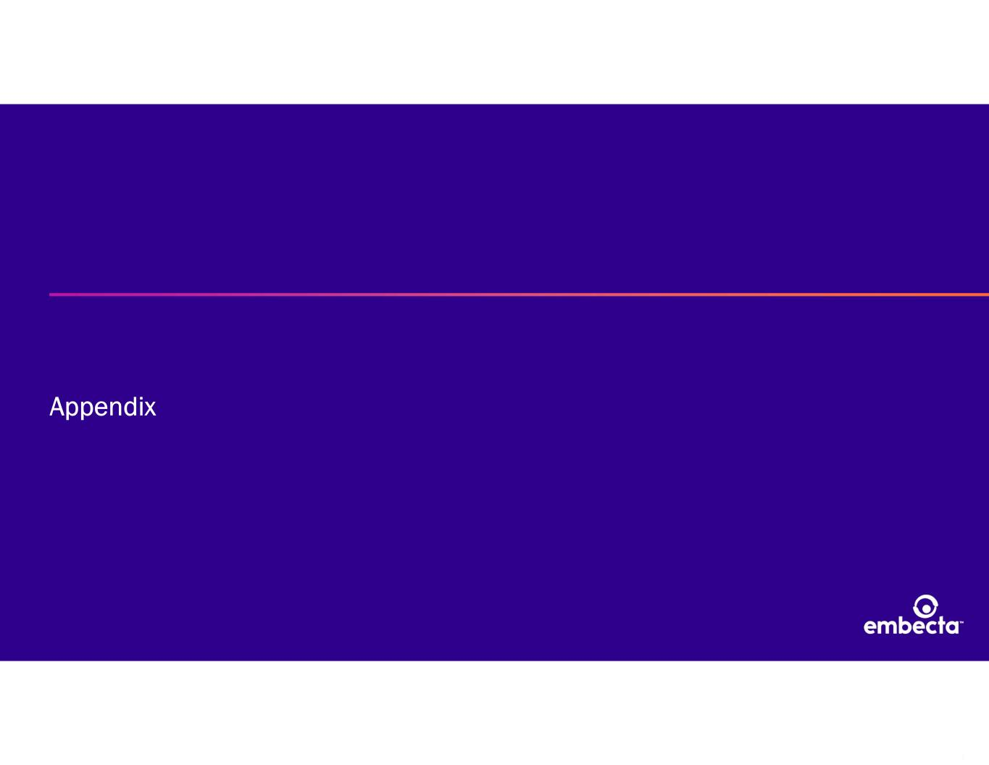
16 Appendix

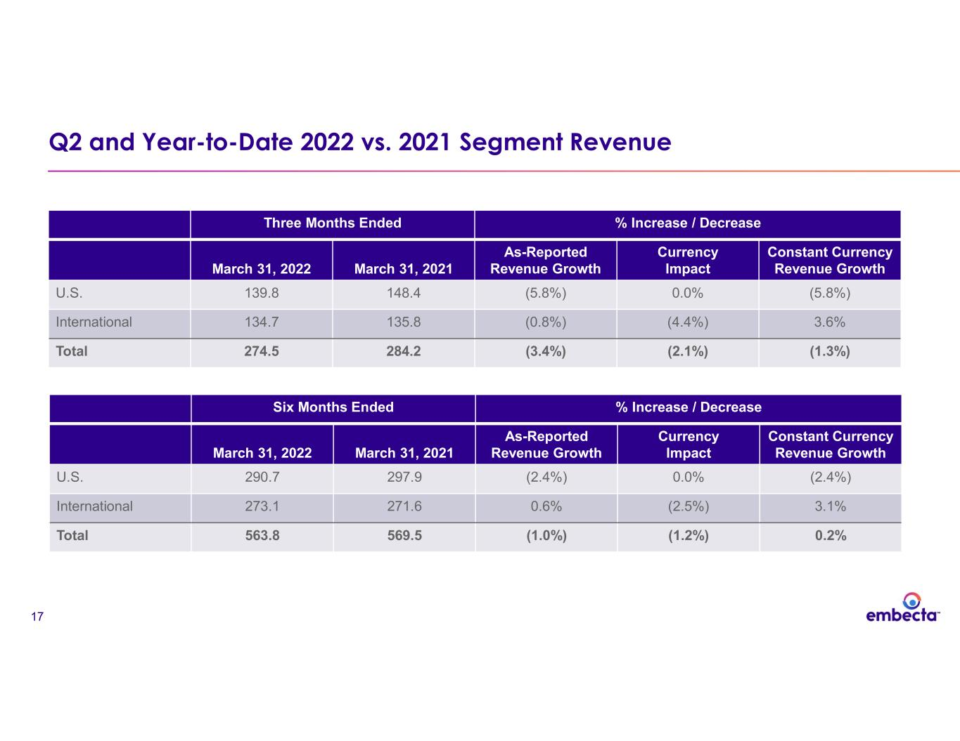
17 Q2 and Year-to-Date 2022 vs. 2021 Segment Revenue Three Months Ended % Increase / Decrease March 31, 2022 March 31, 2021 As-Reported Revenue Growth Currency Impact Constant Currency Revenue Growth U.S. 139.8 148.4 (5.8%) 0.0% (5.8%) International 134.7 135.8 (0.8%) (4.4%) 3.6% Total 274.5 284.2 (3.4%) (2.1%) (1.3%) Six Months Ended % Increase / Decrease March 31, 2022 March 31, 2021 As-Reported Revenue Growth Currency Impact Constant Currency Revenue Growth U.S. 290.7 297.9 (2.4%) 0.0% (2.4%) International 273.1 271.6 0.6% (2.5%) 3.1% Total 563.8 569.5 (1.0%) (1.2%) 0.2%

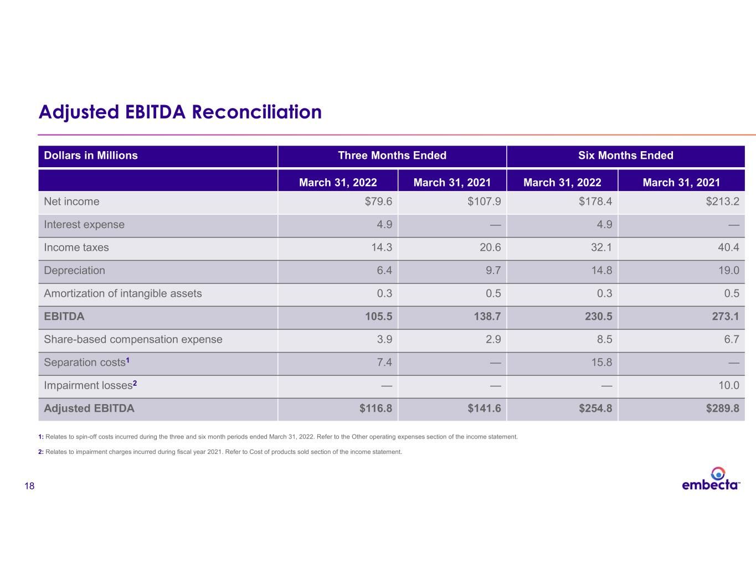
18 Adjusted EBITDA Reconciliation Dollars in Millions Three Months Ended Six Months Ended March 31, 2022 March 31, 2021 March 31, 2022 March 31, 2021 Net income $79.6 $107.9 $178.4 $213.2 Interest expense 4.9 — 4.9 — Income taxes 14.3 20.6 32.1 40.4 Depreciation 6.4 9.7 14.8 19.0 Amortization of intangible assets 0.3 0.5 0.3 0.5 EBITDA 105.5 138.7 230.5 273.1 Share-based compensation expense 3.9 2.9 8.5 6.7 Separation costs1 7.4 — 15.8 — Impairment losses2 — — — 10.0 Adjusted EBITDA $116.8 $141.6 $254.8 $289.8 1: Relates to spin-off costs incurred during the three and six month periods ended March 31, 2022. Refer to the Other operating expenses section of the income statement. 2: Relates to impairment charges incurred during fiscal year 2021. Refer to Cost of products sold section of the income statement.

